

***Cecil Arthur Pratt***

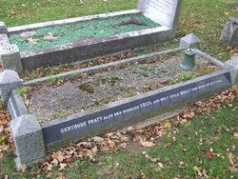

***Parish:*** *Wickford*

|  |  |  |  |  |  |  |  |  |  |  |  |  |  |  |  |  |  |  |  |  |  |  |
| --- | --- | --- | --- | --- | --- | --- | --- | --- | --- | --- | --- | --- | --- | --- | --- | --- | --- | --- | --- | --- | --- | --- |
| |  |  | | --- | --- | | *Birthplace :* | *Ongar,Essex* | | *Residence :* | *Stoke Teign, Swan Lane, Wickford* | | *Date of Death :* | *2nd October 1940* | | *Age at Death :* | *56* | | *Death Location :* | *Stoke Teign, Swan Lane, Wickford* | | *Type of Casualty :* | *Civilian* | | *Cemetery :* | *Wickford Cemetery. Buried in same grave with Wife Gertrude Hannah and daughter Judith Mary Molly Pratt* | | *Grave Ref :* |  | | *Local War Memorial :* | *Wickford* | | *Other Information :* | *Son of the late C.I. Pratt of Foxboro Hall Farm, Melton. Husband of Gertrude Hannah Pratt.* | | |  |
|  |  | |
|  |  | |
|  |  | |
|  |  | |
|  |  | |
|  |  | |
|  |  | |
|  |  | |
|  |  | |
|  |  | |
|  |  | |